### **Design agency**

### **Aim**

To create a modern, visually engaging, and informative UI for a design agency’s website using Figma.

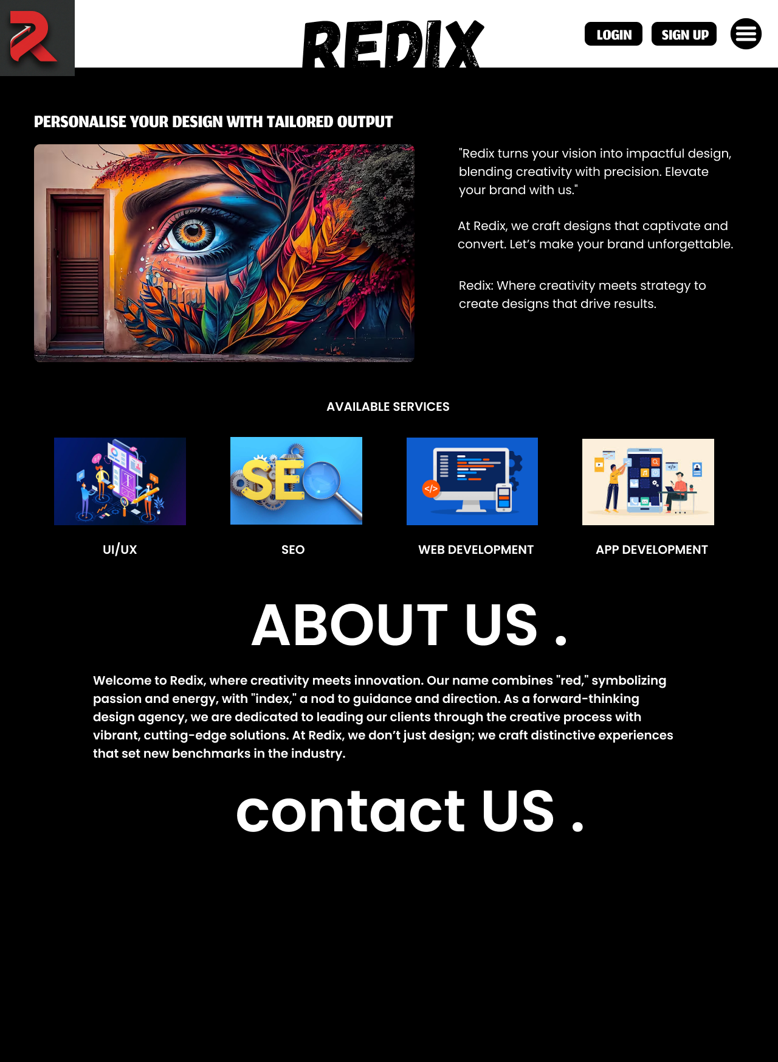

### **Procedure**

1. **Initial Wireframing**:
   * Created a basic wireframe layout to determine the structure and placement of key elements (e.g., header, service sections, and "About Us" section).
   * Utilized Figma’s built-in wireframe kits for quick prototyping.
2. **Component Creation**:
   * Designed reusable components like navigation bars, service icons, and footer elements.
   * Leveraged Figma’s auto-layout feature to maintain consistent spacing and alignment.
3. **Typography and Color Scheme**:
   * Selected bold, modern fonts to make the text readable and impactful.
   * Incorporated a color scheme centered around black, white, and accent colors to ensure a professional look. Used red accents to align with the theme of "Redix."
4. **Visual Elements and Images**:
   * Added high-resolution images and custom illustrations to visually support the theme.
   * Used Figma's vector tools to create and modify illustrations as needed.
5. **Responsive Design**:
   * Ensured the design adapts well to different screen sizes by creating variations for desktop, tablet, and mobile views.
   * Used Figma’s constraints feature to align elements proportionally.

### **Result**

The completed design in Figma resulted in a clean, visually appealing website interface for "Redix" that effectively communicates the agency’s values and services. The final UI includes strategically placed visuals and text for an engaging user experience and reflects modern design trends suitable for a forward-thinking design agency.